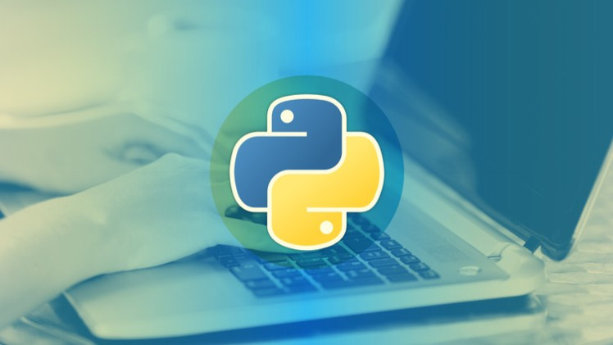
Ms. Karen Pruss, Business, Computer & IT Teacher

8th Grade: Business, Computer & IT Class Overview
In BCIT class, we will be diving into exciting and valuable topics that will inspire your child and prepare them for real-world challenges: Python programming and Financial Literacy. By integrating these two areas, students will develop essential problem-solving and critical-thinking skills while learning to make smart financial decisions.
- Python Programming: Using the Learning.com platform, students will learn the fundamentals of Python programming with a focus on data.
  - Essential Skills: Python programming is key for developing problem-solving skills, collaboration with peers, logical thinking, and creativity.
  - Real-world Applications: Projects are based upon real-world examples.

  - Flexible Learning: Students will work on individual projects at their own pace, aiming for personal excellence.
- Financial Literacy: Students will explore important life skills including:
  - Employment, applying for a job, reading a paystub, and child labor laws.
  - Money management, budgeting, online banking, and investing in stocks.

Class Structure


- 8th Grade Specials Rotation: Meets every other day for two marking periods.

- Canvas Learning Management System: All lessons and assignments are available on Canvas, Neshaminy’s learning management system.
- Absences: Missed a day? No problem – students can find everything they need in Canvas to stay on track.
- Resubmissions Encouraged: Mistakes are a part of learning. Students can resubmit assignments for regrading without penalty.

 |  | Contact: |  | Email:
 |  | 215-809-7674 |  | kpruss@neshaminy.org

